

**Polling District and Polling Place Review 2025**

**Kingston Park and Dinnington Ward**

**Parliamentary Constituency:** Cramlington and Killingworth | Hexham | North

**(Proposed) Polling Districts:** O01, O02, O03, O04, O05

The Local Government Boundary Commission for England are an independent body accountable to Parliament. They are responsible for reviewing councils to make sure their patterns of internal wards are fair and sensible. Their reviews include at least two rounds of public consultation before they make recommendations for change.

The final recommendations were published on 7 January 2025, and the new arrangements apply to local elections from 2026.

As a result of changes to ward boundaries the Acting Returning Officer (ARO) is conducting a review of polling districts and polling places to ensure that they are suitable for the new ward boundaries.

For more information on the local government boundary review visit: <https://www.lgbce.org.uk/all-reviews/newcastle-upon-tyne>

This document provides details of the review, along with the initial recommendations and comments of the Acting Returning Officer (ARO). Also, the election rules require the ARO to decide how many polling stations are required for each polling station and the ARO must allocate electors to the polling stations in such manner as they think most convenient.

These recommendations will be open to all residents, stakeholders, and any interested parties. We shall be seeking representations from local disability groups on the accessibility and suitability of polling places. Any comments should be addressed in the first instance to pollingplaces@newcastle.gov.uk where they will be collated on behalf of the (Acting) Returning Officer.

We considered the following factors:

* **Identifying new polling places:** We will look for new polling places in areas where the existing provision is unsuitable or unavailable.
* **Feedback:** We will consider feedback received following recent elections, consultation from members of the public, elected members, and other stakeholders.
* **Accessibility:** We will try to ensure that every polling place is accessible to electors with disabilities.
* **Facilities**: We will make sure that all electors have such reasonable facilities for voting as are practicable in the circumstances.
* **Elector numbers:** We will try to comply with the Electoral Commission guidance on the maximum number of electors that should be allocated to a polling station which should not exceed 2,250.
* **Future housing developments**: We will consider the impact of proposed housing developments on polling station electorates.

**(Current) Castle**

The maps below show the current wards and polling district boundaries and the polling places.

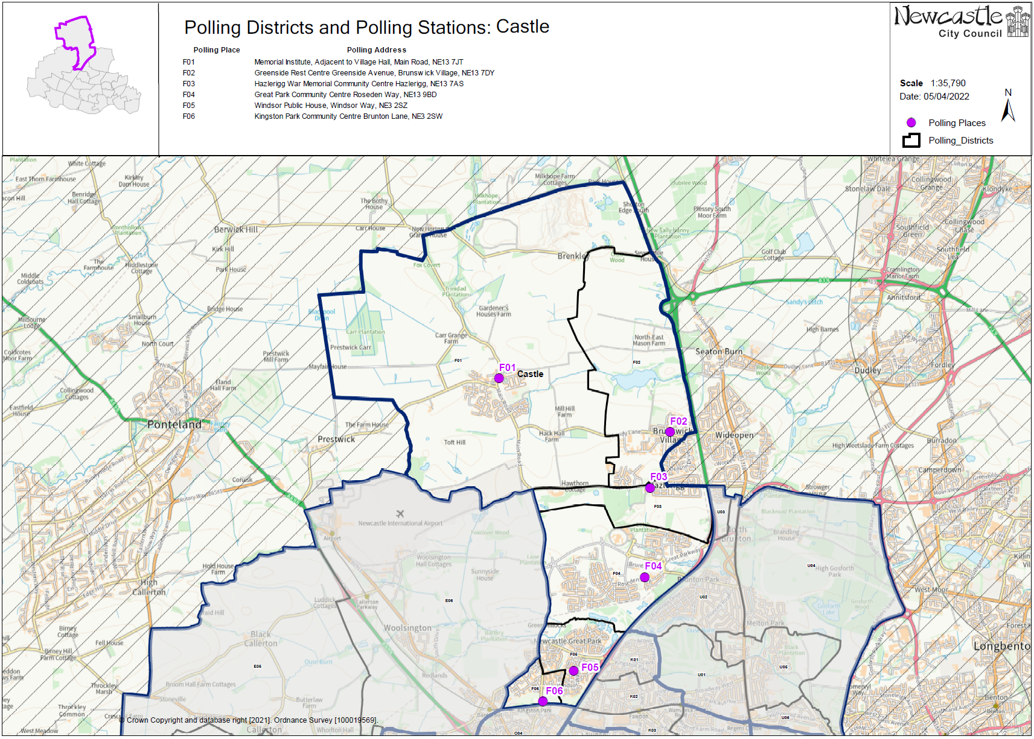

**(Current) Callerton and Throckley**

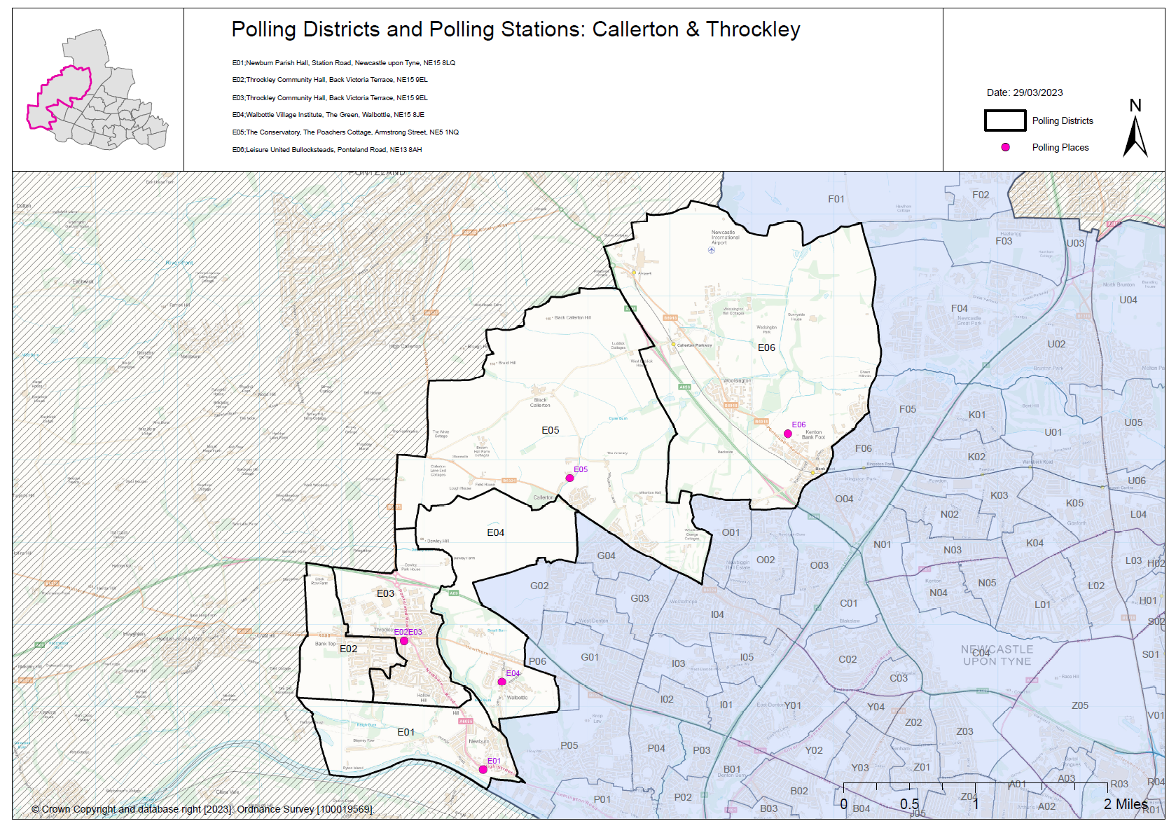

**(Current) Kingston Park South & Newbiggin Hall**

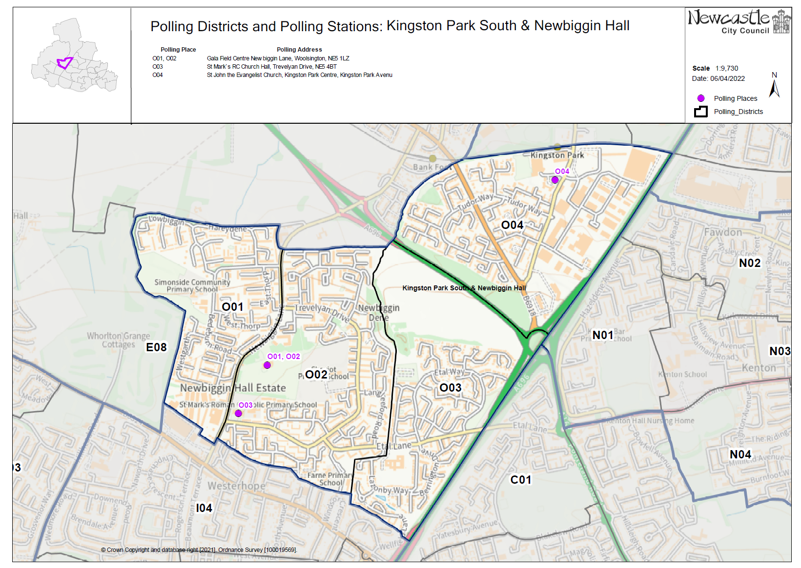

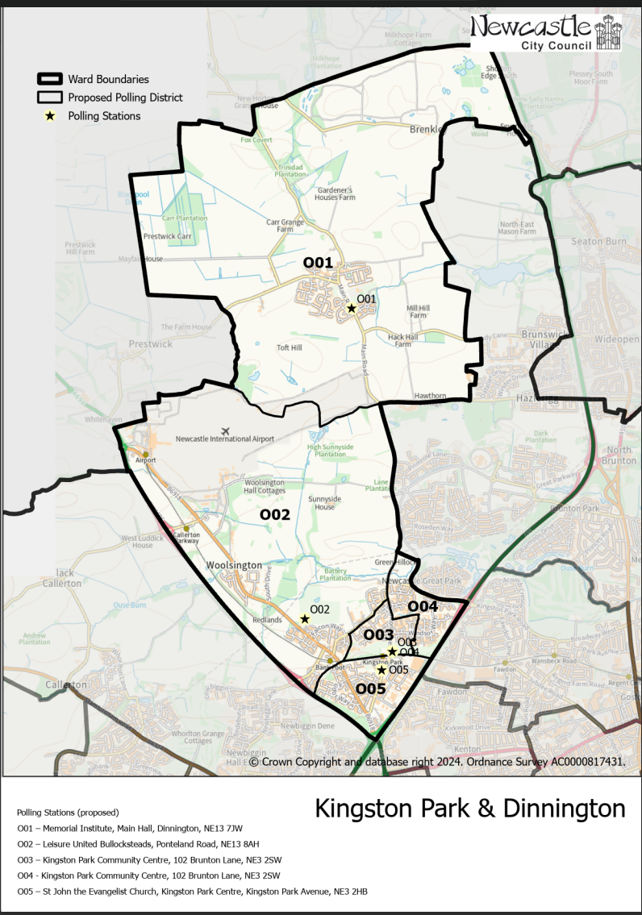**(New)**

**Kingston Park and Dinnington Ward**

This map shows the new ward and the proposed polling districts and the proposed polling places.

* **O01** – Memorial Institute, Main Hall, Dinnington, NE13 7JW
* **O02** – Leisure United Bullocksteads, Ponteland Road, NE13 8AH
* **O03** – Kingston Park Community Centre, 102 Brunton Lane, NE3 2SW
* **O04** – Kingston Park Community Centre, 102 Brunton Lane, NE3 2SW
* **O05** – St John the Evangelist Church, Kingston Park Centre, Kingston Park Avenue, NE3 2HB

**Kingston Park and Dinnington Ward**

**Polling District O01**

|  |  |  |
| --- | --- | --- |
| **Current Polling District** | | **Current Polling Place** |
| F01 (Part of)  F02* (Part of) | | Memorial Institute, Main Hall, Dinnington, NE13 7JW |
|  | | |
| **Proposed Polling District** | **Predicted Polling Station Electorate** | **Proposed Polling Place** |
| O01 | 1294 | Memorial Institute, Main Hall, Dinnington, NE13 7JW |
|  | | |
| **Considerations and Proposals** | | |
| Most of the current F01 district from Castle ward, moves into Kingston Park and Dinnington ward and is proposed to become the new O01 district.  No change to the polling place. | | |
|  | | |
| **Preliminary Consultation – Elected Members comments and feedback** | | |
| No comments received. | | |

**Kingston Park and Dinnington Ward**

**Polling District O02**

|  |  |  |
| --- | --- | --- |
| **Current Polling District** | | **Current Polling Place** |
| E06 (Part of) | | Leisure United Bullocksteads, Ponteland Road, NE13 8AH |
|  | | |
| **Proposed Polling District** | **Predicted Polling Station Electorate** | **Proposed Polling Place** |
| O02 | 929 | Leisure United Bullocksteads, Ponteland Road, NE13 8AH |
|  | | |
| **Considerations and Proposals** | | |
| Part of the current E06 district from the previous Callerton and Throckley ward, moves into the new Kingston Park and Dinnington ward and is proposed to become the new O02 district.  No change to the polling place. | | |
|  | | |
| **Preliminary Consultation – Elected Members comments and feedback** | | |
| No comments received. | | |

**Kingston Park and Dinnington Ward**

**Polling District O03**

|  |  |  |
| --- | --- | --- |
| **Current Polling District** | | **Current Polling Place** |
| F06 (full) | | Kingston Park Community Centre, 102 Brunton Lane, NE3 2SW |
|  | | |
| **Proposed Polling District** | **Predicted Polling Station Electorate** | **Proposed Polling Place** |
| O03 | 774 | Kingston Park Community Centre, 102 Brunton Lane, NE3 2SW |
|  | | |
| **Considerations and Proposals** | | |
| Current F06 district from Castle ward, moves into Kingston Park and Dinnington ward to become the proposed O03 district.  No change to the polling place. Kingston Park Community Centre is suggested to be used as a polling station for electors from three proposed districts, O03, O04 and E05. | | |
|  | | |
| **Preliminary Consultation – Elected Members comments and feedback** | | |
| No comments received. | | |

**Kingston Park and Dinnington Ward**

**Polling District O04**

|  |  |  |
| --- | --- | --- |
| **Current Polling District** | | **Current Polling Place** |
| F05 (part of) | | Windsor Public House, Windsor Way, NE3 2SZ |
|  | | |
| **Proposed Polling District** | **Predicted Polling Station Electorate** | **Proposed Polling Place** |
| O04 | 886 | Kingston Park Community Centre, 102 Brunton Lane, NE3 2SW |
|  | | |
| **Considerations and Proposals** | | |
| Part of current F05 would become the proposed O04. Incorporates properties south of Kingston Park Road.  Anti-social behaviour forces a move away from the Windsor Public House. Kingston Park Community Centre is in the neighbouring O03 district and is a current polling station, therefore meets accessibility requirements.  No change to the polling place. Kingston Park Community Centre is suggested to be used as a polling station for electors from three proposed districts, O03, O04 and E05. | | |
|  | | |
| **Preliminary Consultation – Elected Members comments and feedback** | | |
| No comments received. | | |

**Kingston Park and Dinnington Ward**

**Polling District O05**

|  |  |  |
| --- | --- | --- |
| **Current Polling District** | | **Current Polling Place** |
| O04 (full) | | St John the Evangelist Church, Kingston Park Centre, Kingston Park Ave, NE3 2HB |
|  | | |
| **Proposed Polling District** | **Predicted Polling Station Electorate** | **Proposed Polling Place** |
| O05 | 748 | St John the Evangelist Church, Kingston Park Centre, Kingston Park Ave, NE3 2HB |
|  | | |
| **Considerations and Proposals** | | |
| Current O04 would become the proposed O05. No change to the polling district boundary.  No change to the polling place. | | |
|  | | |
| **Preliminary Consultation – Elected Members comments and feedback** | | |
| No comments received. | | |

THIS PAGE IS INTENTIONALLY BLANK